Opgave nr 1

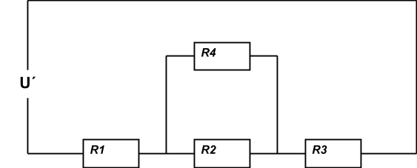

Beregn de resterende værdier :

|  |  |  |  |  |  |
| --- | --- | --- | --- | --- | --- |
|  | **R1** | **R2** | **R3** | **R4** | **Rtot** |
| **U** |  |  |  | **40V** | **125V** |
| **I** | **3,5A** |  |  |  |  |
| **R** |  | **20Ω** | **20Ω** |  |  |

Formler og beregninger :

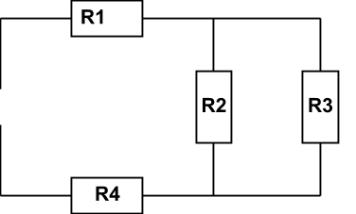

Beregn de resterende værdier :

|  |  |  |  |  |  |
| --- | --- | --- | --- | --- | --- |
|  | **R1** | **R2** | **R3** | **R4** | **Rtot** |
| **U** | **25V** |  |  | **40V** |  |
| **I** |  | **1,5A** |  |  | **5A** |
| **R** |  |  | **10Ω** |  |  |

Formler og beregninger :

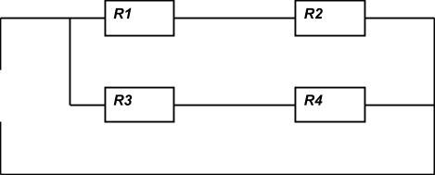

Beregn de resterende værdier :

|  |  |  |  |  |  |
| --- | --- | --- | --- | --- | --- |
|  | **R1** | **R2** | **R3** | **R4** | **Rtot** |
| **U** | **30V** |  |  | **45V** | **75V** |
| **I** |  | **2,3A** | **2,7A** |  |  |
| **R** |  |  |  |  |  |

Formler og beregninger :

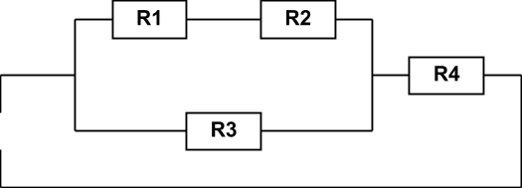

Beregn de resterende værdier :

|  |  |  |  |  |  |
| --- | --- | --- | --- | --- | --- |
|  | **R1** | **R2** | **R3** | **R4** | **Rtot** |
| **U** | **20V** |  | **35V** |  | **50V** |
| **I** |  | **2A** |  | **3A** |  |
| **R** |  |  |  |  |  |

Formler og beregninger :

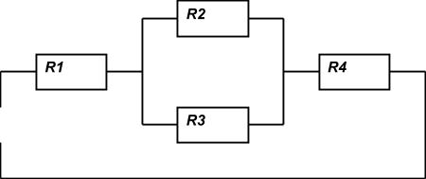

Beregn de resterende værdier :

|  |  |  |  |  |  |
| --- | --- | --- | --- | --- | --- |
|  | **R1** | **R2** | **R3** | **R4** | **Rtot** |
| **U** |  | **30V** |  |  | **220V** |
| **I** |  |  |  | **4A** |  |
| **R** | **40Ω** | **20Ω** |  |  |  |

Formler og beregninger :



Beregn de resterende værdier :

|  |  |  |  |  |  |
| --- | --- | --- | --- | --- | --- |
|  | **R1** | **R2** | **R3** | **R4** | **Rtot** |
| **U** |  |  |  |  | **24V** |
| **I** |  |  | **2A** |  | **6A** |
| **R** | **8Ω** | **16Ω** |  |  |  |

Formler og beregninger :



Beregn de resterende værdier :

|  |  |  |  |  |  |
| --- | --- | --- | --- | --- | --- |
|  | **R1** | **R2** | **R3** | **R4** | **Rtot** |
| **U** |  |  |  | **80V** |  |
| **I** | **5A** |  | **2A** |  |  |
| **R** |  | **20Ω** |  | **40Ω** |  |

Formler og beregninger :

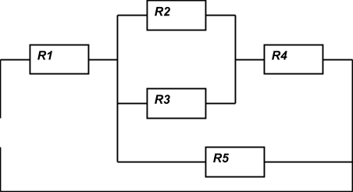

Beregn de

resterende værdier :

|  |  |  |  |  |  |  |
| --- | --- | --- | --- | --- | --- | --- |
|  | **R1** | **R2** | **R3** | **R4** | **R5** | **Rtot** |
| **U** | **75V** |  |  |  |  | **230V** |
| **I** |  | **2A** |  |  | **1,5A** |  |
| **R** | **15Ω** |  | **45Ω** | **25Ω** |  |  |

Formler og beregninger :

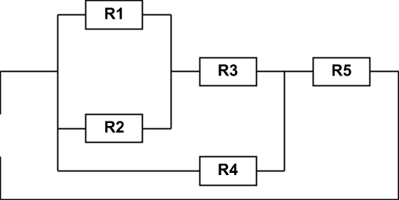

Beregn de resterende værdier :

|  |  |  |  |  |  |  |
| --- | --- | --- | --- | --- | --- | --- |
|  | **R1** | **R2** | **R3** | **R4** | **R5** | **Rtot** |
| **U** |  |  |  |  |  | **230V** |
| **I** |  |  |  |  |  |  |
| **R** | **10Ω** | **30Ω** | **12,5Ω** | **30Ω** | **8Ω** |  |

Formler og beregninger :

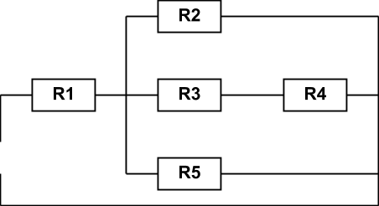

Beregn de resterende værdier :

|  |  |  |  |  |  |  |
| --- | --- | --- | --- | --- | --- | --- |
|  | **R1** | **R2** | **R3** | **R4** | **R5** | **Rtot** |
| **U** |  |  |  |  | **25V** | **40V** |
| **I** | **3,2A** |  |  | **0,2A** |  |  |
| **R** |  | **19,23Ω** | **30Ω** |  |  |  |

Formler og beregninger :

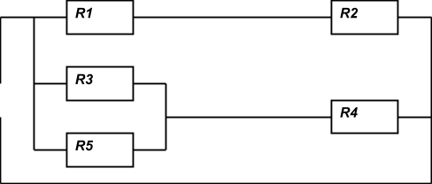

Beregn de resterende værdier :

|  |  |  |  |  |  |  |
| --- | --- | --- | --- | --- | --- | --- |
|  | **R1** | **R2** | **R3** | **R4** | **R5** | **Rtot** |
| **U** |  |  | **20V** |  |  | **50V** |
| **I** | **1A** |  |  | **3,5A** | **1,5A** |  |
| **R** |  | **15Ω** |  |  |  |  |

Formler og beregninger :

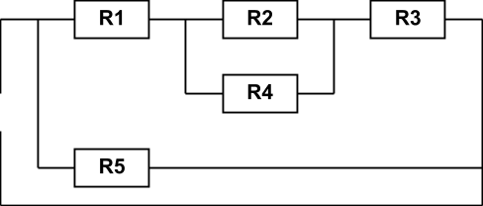

Beregn de resterende værdier :

|  |  |  |  |  |  |  |
| --- | --- | --- | --- | --- | --- | --- |
|  | **R1** | **R2** | **R3** | **R4** | **R5** | **Rtot** |
| **U** |  | **115V** |  |  | **230V** |  |
| **I** | **3,2A** |  |  | **1,4A** |  | **4,5A** |
| **R** |  |  | **19Ω** |  |  |  |

Formler og beregninger :

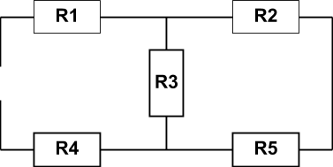

Beregn de resterende værdier :

|  |  |  |  |  |  |  |
| --- | --- | --- | --- | --- | --- | --- |
|  | **R1** | **R2** | **R3** | **R4** | **R5** | **Rtot** |
| **U** |  |  |  |  |  | **40V** |
| **I** |  |  |  |  |  |  |
| **R** | **3Ω** | **8Ω** | **11Ω** | **17Ω** | **9Ω** |  |

Formler og beregninger :

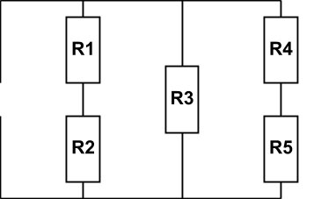

Beregn de resterende værdier :

|  |  |  |  |  |  |  |
| --- | --- | --- | --- | --- | --- | --- |
|  | **R1** | **R2** | **R3** | **R4** | **R5** | **Rtot** |
| **U** |  |  |  |  | **25V** | **75V** |
| **I** | **1,5A** |  |  | **4A** |  |  |
| **R** |  | **20Ω** | **20Ω** |  |  |  |

Formler og beregninger :

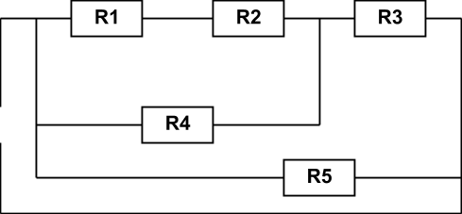

Beregn de resterende værdier :

|  |  |  |  |  |  |  |
| --- | --- | --- | --- | --- | --- | --- |
|  | **R1** | **R2** | **R3** | **R4** | **R5** | **Rtot** |
| **U** |  | **25V** |  |  | **100V** |  |
| **I** |  |  | **4A** | **2,5A** |  | **5A** |
| **R** | **6,66Ω** |  |  |  |  |  |

Formler og beregninger :