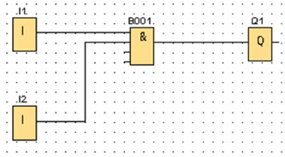

**Sandhedstabel 1**

|  |  |  |
| --- | --- | --- |
| **Input 1** | **Input 2** | **Output 1** |
| **1** | **0** |  |
| **0** | **1** |  |
| **1** | **1** |  |
| **0** | **1** |  |

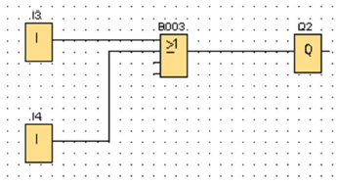

**Sandhedstabel 2**

|  |  |  |
| --- | --- | --- |
| **Input 3** | **Input 4** | **Output 2** |
| **1** | **1** |  |
| **0** | **0** |  |
| **1** | **0** |  |
| **0** | **1** |  |

**Sandhedstabel 3**

|  |  |  |  |  |
| --- | --- | --- | --- | --- |
| **Input 1** | **Input 2** | **Input 3** | **Input 4** | **Output 1** |
| **1** | **1** | **1** | **0** |  |
| **0** | **0** | **0** | **1** |  |
| **1** | **0** | **1** | **0** |  |
| **0** | **1** | **0** | **1** |  |
| **1** | **1** | **0** | **0** |  |
| **0** | **0** | **1** | **1** |  |
| **0** | **0** | **1** | **0** |  |
| **1** | **1** | **0** | **1** |  |
| **1** | **1** | **1** | **1** |  |

**Sandhedstabel 4**

|  |  |  |  |  |
| --- | --- | --- | --- | --- |
| **Input 1** | **Input 2** | **Input 3** | **Input 4** | **Output 1** |
| **1** | **1** | **1** | **0** |  |
| **0** | **0** | **0** | **1** |  |
| **1** | **0** | **1** | **0** |  |
| **0** | **1** | **0** | **1** |  |
| **1** | **1** | **0** | **0** |  |
| **0** | **0** | **1** | **1** |  |
| **0** | **0** | **1** | **0** |  |
| **1** | **1** | **0** | **1** |  |
| **1** | **1** | **1** | **1** |  |

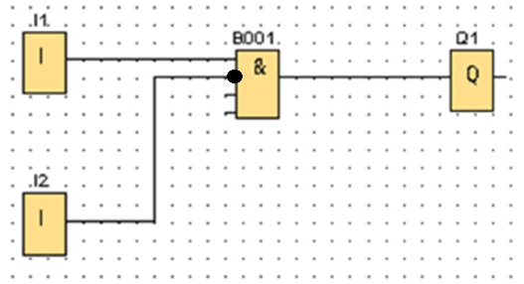

**Sandhedstabel 5**

|  |  |  |
| --- | --- | --- |
| **Input 1** | **Input 2** | **Output 1** |
| **1** | **0** |  |
| **0** | **1** |  |
| **1** | **1** |  |
| **0** | **1** |  |

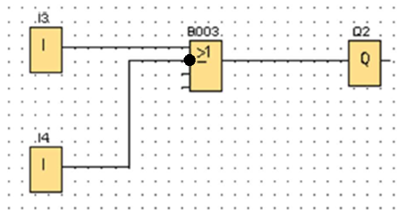

**Sandhedstabel 6**

|  |  |  |
| --- | --- | --- |
| **Input 3** | **Input 4** | **Output 2** |
| **1** | **1** |  |
| **0** | **0** |  |
| **1** | **0** |  |
| **0** | **1** |  |

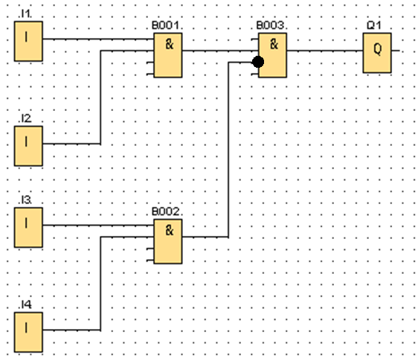

**Sandhedstabel 7**

|  |  |  |  |  |
| --- | --- | --- | --- | --- |
| **Input 1** | **Input 2** | **Input 3** | **Input 4** | **Output 1** |
| **1** | **1** | **1** | **0** |  |
| **0** | **0** | **0** | **1** |  |
| **1** | **0** | **1** | **0** |  |
| **0** | **1** | **0** | **1** |  |
| **1** | **1** | **0** | **0** |  |
| **0** | **0** | **1** | **1** |  |
| **0** | **0** | **1** | **0** |  |
| **1** | **1** | **0** | **1** |  |
| **1** | **1** | **1** | **1** |  |

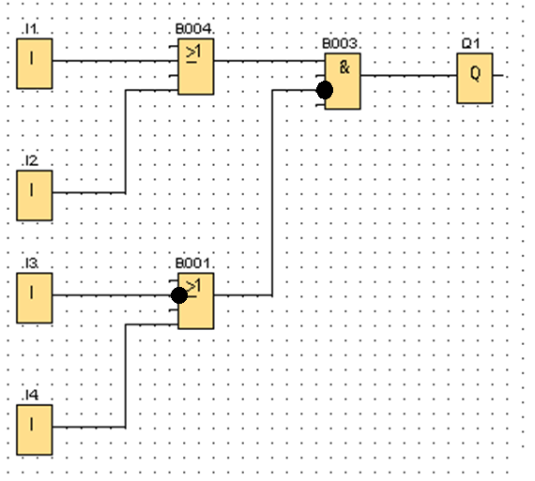

**Sandhedstabel 8**

|  |  |  |  |  |
| --- | --- | --- | --- | --- |
| **Input 1** | **Input 2** | **Input 3** | **Input 4** | **Output 1** |
| **1** | **1** | **1** | **0** |  |
| **0** | **0** | **0** | **1** |  |
| **1** | **0** | **1** | **0** |  |
| **0** | **1** | **0** | **1** |  |
| **1** | **1** | **0** | **0** |  |
| **0** | **0** | **1** | **1** |  |
| **0** | **0** | **1** | **0** |  |
| **1** | **1** | **0** | **1** |  |
| **1** | **1** | **1** | **1** |  |