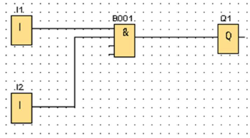
Sandhedstabel 1
Input 1 | Input 2 | Output 1
1 | 0
0 | 1
1 | 1
0 | 1

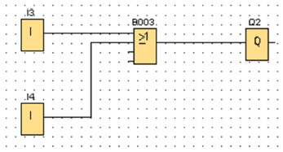
Sandhedstabel 2
Input 3 | Input 4 | Output 2
1 | 1
0 | 0
1 | 0
0 | 1

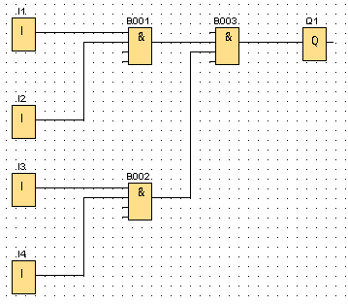
Sandhedstabel 3
Input 1 | Input 2 | Input 3 | Input 4 | Output 1
1 | 1 | 1 | 0
0 | 0 | 0 | 1
1 | 0 | 1 | 0
0 | 1 | 0 | 1
1 | 1 | 0 | 0
0 | 0 | 1 | 1
0 | 0 | 1 | 0
1 | 1 | 0 | 1
1 | 1 | 1 | 1

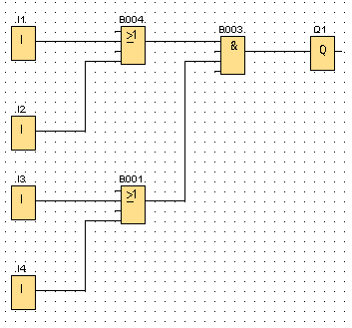
Sandhedstabel 4
Input 1 | Input 2 | Input 3 | Input 4 | Output 1
1 | 1 | 1 | 0
0 | 0 | 0 | 1
1 | 0 | 1 | 0
0 | 1 | 0 | 1
1 | 1 | 0 | 0
0 | 0 | 1 | 1
0 | 0 | 1 | 0
1 | 1 | 0 | 1
1 | 1 | 1 | 1

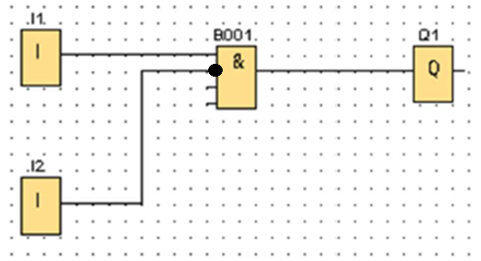
Sandhedstabel 5
Input 1 | Input 2 | Output 1
1 | 0
0 | 1
1 | 1
0 | 1

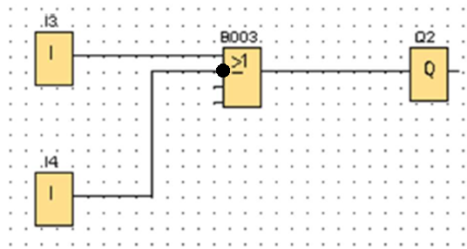
Sandhedstabel 6
Input 3 | Input 4 | Output 2
1 | 1
0 | 0
1 | 0
0 | 1

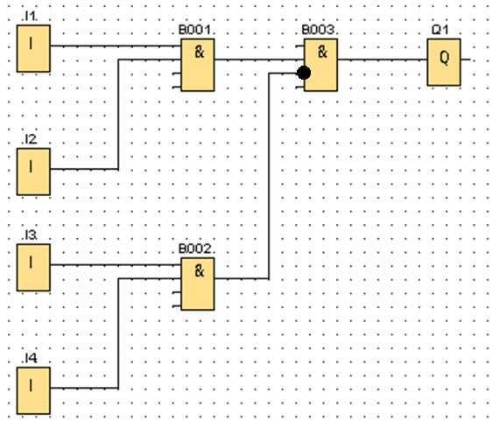
Sandhedstabel 7
Input 1 | Input 2 | Input 3 | Input 4 | Output 1
1 | 1 | 1 | 0
0 | 0 | 0 | 1
1 | 0 | 1 | 0
0 | 1 | 0 | 1
1 | 1 | 0 | 0
0 | 0 | 1 | 1
0 | 0 | 1 | 0
1 | 1 | 0 | 1
1 | 1 | 1 | 1

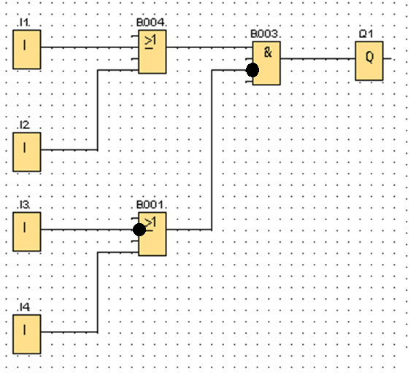
Sandhedstabel 8
Input 1 | Input 2 | Input 3 | Input 4 | Output 1
1 | 1 | 1 | 0
0 | 0 | 0 | 1
1 | 0 | 1 | 0
0 | 1 | 0 | 1
1 | 1 | 0 | 0
0 | 0 | 1 | 1
0 | 0 | 1 | 0
1 | 1 | 0 | 1
1 | 1 | 1 | 1

